Hyperbolic Equations:
INTRODUCTION:

The wave equation in one dimension (vibration of strings) is
a² 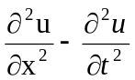 = 0
i.e., a²u_{xx} – u_{tt} = 0.
Here, A = a², B = 0, C = -1 B² – 4AC = 4a² = + ve.
Therefore, the equation is hyperbolic.
Let us solve this equation by reducing it to difference equation.

AIM:
Solve a²u_{xx} – u_{tt} = 0 …..(1)
Together with the boundary conditions
u(0,t) = 0 …..(2)
u(l,t) = 0 …..(3)
and the initial conditions
u(x,0) = f(x) …..(4)
u_{t}(x,0) = 0 …..(5)
Assumption Δx = h, Δt = k, we have

u_{xx} = 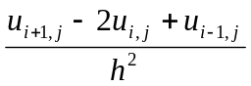
u_{tt} = 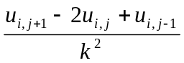
substituting these values in (1),

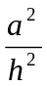 (u_{i+1,j} -2 u_{i,j}+ u_{i-1,j}) - 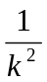 (u_{i,j+1} -2 u_{i,j} + u_{i,j-1}) = 0

i.e., λ²a²(u_{i+1,j} -2u_{i,j}+u_{i-1,j}) – u_{i,j+1}+ 2u_{i,j}- u_{i,j-1} = 0
where, λ = 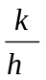

u_{i,j+1} = 2(1-λ²a²)u_{i,j} + λ²a²(u_{i-1,j} + u_{i+1,j}) – u_{i,j-1}
To make the equation simpler, select λ such that

1-λ²a² = 0 i.e., λ² = 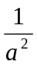= 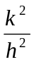i.e., k = 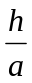
Under this selection of λ² = ; i.e., k = , the equation (6) reduces to the simplest form

u_{i,j+1} = u_{i-1,j} + u_{i+1,j} – u_{i,j-1} .....(7)
Equation (6) is called an Explicit scheme or Explicit formula to solve the wave equation.
Equation (7) gives a simpler form under the condition k =.

PROBLEMS:

1. Solve numerically, 4 u_{xx} = u_{tt} with the boundary conditions u (0, t) = 0,
u (4, t) = 0 and the initial conditions u_{t} (x, 0) = 0 and u (x, 0) = x(4 –x), taking h = 1. (for 4 times steps)
SOL:

Since a² = 4, h = 1, k = h/a = 1/2 ….(1)

Taking k = 1/2 , we use the formula,

u_{i,j+1} = u_{i-1,j} + u_{i+1,j} – u_{i,j-1} ….(2)
From u(0,t) = 0 ⇒ u along x = 0 are all zero
From u(4,t) = 0 ⇒ u along x = 4 are all zero.

u (x, 0) = x (4-x) implies that

u (0, 0) = 0, u (1,0) = 3, u(2,0) = 4, u(3, 0) = 3.

Now, we fill up the row t = 0 using the above values,

u_{t}(x,0) = 0, implies u_{i,j} = 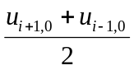 ….(3)

Now we draw the table; for that we require

u_{i,1} = 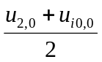= 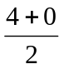= 2

u_{2,1} = 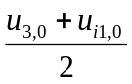= 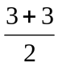= 3

u_{3,1} = 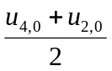= 2

u_{4,1} = 0.

Table

t \ x | 0 | 1 | 2 | 3 | 4
0  0.5  1  1.5  2  2.5  3  3.5  4 | 0  0  0  0  0  0  0  0  0 | 3  2  0  -2  -3  -2  0  2  3 | 4  3  0  -3  -4  -3  0  3  4 | 3  2  0  -2  -3  -2  0  2  3 | 0  0  0  0  0  0  0  0  0

Period is 4 seconds or 8 (k) = 8(1/2) = 4 secs

2. Evaluate the pivotal values of the following equation taking h=1and upto one half of the period of the oscillation 16u_{xx} = u_{tt} given
u(0,t) = u(5,t) = 0,u(x,0) = x²(5-x) and u(x,0) = 0.

SOL:
Here a²=16 ... a=4

Period of oscillation = 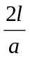=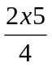=secs

... one half of the period = secs.
k = 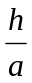= 
Step-size of time=

u(0,t) = 0 ⇒ u₀,_{j} = 0

u(5,t) = 0 ⇒ u_{5,j} = 0 for all j

u(x,0) = x²(5-x)

⇒ u(0,0) = 0, u(1,0) = 4, u(2,0) = 12 , u(3,0) =18, u(4,0) = 16, u(5,0) = 0

u_{t}(x,0) = 0 ⇒ u_{i,1} = 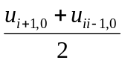

u_{1,1} = = 6

u_{2,1} = 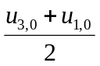 = 11

u_{3,1} = 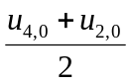 = 14

u_{4,1} = 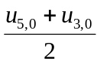= 9

Now we form the table(t≠j)

t \ x | 0 | 1 | 2 | 3 | 4 | 5
0  0.25  0.5  0.75  1.0  1.25 | 0  0  0  0  0  0 | 4  6  7  2  -9  -16 | 12  11  8  -2  -14  -18 | 18  14  2  -8  -11  -12 | 16  9  -2  -7  -6  -4 | 0  0  0  0  0  0

